**Analysis of Smart phone data**

**Assignment-1**

**MIS771 – Descriptive Analytics and Visualisation**

**Shantanu Gupta**

**Student Id: 218200234**

**Introduction:**

This report conduct a preliminary analysis of smartphone usage in Australia. In Australia there are close to twenty three million business buyers. For 2017, the number of smartphone users in Australia is estimated to have 16.69 million. These differences are important in understanding the behaviour of business services and consumer satisfaction and consumer markets. So, to delve deeper I have perform a series of descriptive and inferential analyses on the 150 randomly customer data and produce one report based on all the findings I got. This report is especially useful for the telecom companies, or those companies who wanted to step their telecom business in Australia. By reading this report, the companies can improve their operations, marketing strategy, customer churn etc., in this digital and competitive world. The report also includes on the user’s expenditure, usage patterns, satisfaction levels and demographics.

This report submitted in fulfilment of the requirements for publishing the article in Business Insider in collaboration with BI Intelligence. BI Intelligence is a business insider paid research service. It was aimed to cater reports on key digital areas like mobile industry, specifically for the needs of big companies, investors and tech reader.

**Body:**

**To:** Sam Edmondson

**From:** Lee Slattery

**Subject:** Analysis of Smartphone data

Dear Sam,

Thank you for your e-mail. After properly reviewing your concerns I have analysed and came up with the following observations on your findings. Hope this fulfils your concerns.

**Q1.**

The average Australian spends in smartphone data of 150 customers participated in the survey is around $68 in the monthly bill .If you want more precise figure then it is $64.Therefore,50% of the Australians have the bill of $64 or less monthly bill and 50 % of the Australians have more than $64 or more. I can say that the most common monthly bill is $50. The minimum monthly bill is $11 & the maximum monthly bill is $216. The distribution is pointed in the middle. Average Australian monthly bill spending is $64 as data contains high degree of asymmetry. The monthly bill difference between the highest bill and the lowest bill was $205.Furthermore, there was $31.18 average spread away from the mean monthly bill of $67.65.This indicates quite a bit of variation in the spending of monthly bill. More insights that I have found is 25% of the monthly bill is less than or equal to $49 and on 75% have the monthly bill is greater than $49.More deeply I have found that 75% of the monthly bill is less than or equal to $84 and 25% of is greater than $84. The majority of the data that will clustered around average value will lie between these regions $36.42 & $98.78. Most of the times we get the monthly bill within this interval. The middle 50% of our data is within $50 to $84.5.The lower 25% of the data is between $85 and $216, while upper 25% of the data is between $11 to $49.62.As an approximation when we select any person monthly bill we get the error of +/-2.5%. If we visualize data of monthly bill in the form of a graph then we find that there are most of the values are concentrated in the lower portion of the distribution. The tail on the right side is longer or fatter than the left side. The mass of the distribution is concentrated on the left of the figure. Distribution is shorter, tails are thinner than the normal distribution. The peak is lower, which means that data are light-tailed. There was two customer whose average monthly bill is higher than the rest of participants in the survey and thus**,** consideredas an unusual case.

**Q2.a.**

We are 95 percent confident that the true average percentage use of smartphones for work-related activities is between 14.19% to 19.41% of the entire customer base. In other words, I have found that thepercentage of all smart phone owners in Australia that use their phone as a work-related activities is 16.79% with the margin of error is +/-2.6057%.95 percent of the time the data would match this results.

**Q2.b.**

We are 95 percent confident that the true proportion of all smartphone users who are classified as geo tribe ‘Crusaders’ is between 14.78% to 27.89% of the entire customer base. In other words, I have found that theproportion of all smart phone owners in Australia who are classified as geo tribe ‘Crusaders’ is 21.06% with the margin of error is +/-6.83%.95 percent of the time the data would match this results.

I think no. of calls, SMS, and data allowance column should be included in the dataset to make the better profile of the user. This extra column will allows us to get more insight how different geo tribes people are using smartphone services. For example, younger would prefer to spend more in data services than call services as comparison to old people because he wanted to surf internet more like Facebook, YouTube etc. But old people just use the services to call only their relatives.

**Q3.a.**

At 5 percent significance level, there is sufficient evidence to conclude that the average monthly bill of all Australian smart mobile phone user is less than the $72.In other words, average monthly bill of Australian users is less than $72.The industry report claim is correct.

**Q3.b.**

At 5 percent significance level, there is not enough evidence to conclude that 75% of all Australian smartphone customer are either ‘Very Satisfied’ or ‘Moderately Satisfied’ with their service provider. There would be a 7.32% chance of making an error where we think that more or less than (not equal to) 75% Australian smartphone customers are either ‘Very Satisfied’ or ‘Moderately Satisfied’ with their smartphone services. The last year similar study report is correct. This statement is valid.

**Q3.c.**

At 5 percent significance level, there is no sufficient evidence to conclude that there is a difference in the level of satisfaction between male and female customers about their satisfaction for smartphone service provider. In other words, both have the same level of satisfaction between male and female customer towards smartphone services. At 95% confidence, no conclusive results could be drawn regarding the true difference in proportion of the level of satisfaction between male and female customers. As the range contains both negative and positive values it is inconclusive. Unable to say whether one mean is different to the other. Because the interval estimate contains zero, you can conclude that there is insufficient evidence of a difference in the population means. There is insufficient evidence of a difference in the proportion of level of satisfaction between male and female users.

**Q3.d.**

Yes, the data support this proposition. At 5 percent significance level, there is sufficient evidence to conclude that there is a difference in the average monthly bill amounts between the users who are using smartphone as a payment device and those users who are not using smartphone as a payment device. Thus, with 95% confidence, the mean difference in average monthly bill between the users who are using the smartphone as a payment device and those users who are not using smartphone as a payment device is between –$0.83 and $22.55 .As the range contains both negative and positive values it is inconclusive. Unable to say whether one mean is different to the other. Because the interval estimate contains zero, I can conclude that there is a sufficient evidence of a difference in the population means.

**Q3.e.**

No, this is not a valid statement. At 5 percent significance level, there is not enough evidence to conclude that the use of Smartphones for online purchases is higher for users who are highly active in social media than for those users who are moderately active in social media.

**Q4.a.**

At 5 percent significance level, there is not enough evidence to conclude that the proportion of female users is higher than that of male users who are moderately active in social media. Based on these results, there is insufficient evidence to say that the proportion of female users is higher than that of male users who are moderately active in social media.

**Q4.b.**

At 5 percent significance level, there is not enough evidence to conclude that the average monthly bill amount for female users is higher than the male users in which both the groups are moderately active in social media. In other terms, the average monthly bill of male users is more than that of female users who are moderately active in social media.

Sam, I hope that this provides more information to your concerns and these observations will provide you a help to write up your article. Please let me know in case of any other concerns or any further information required from the data set. I will be happy to help you.

Sincerely

Lee Slattery

**Conclusion:**

Improvements in every area of the sector are needed if the company or new entrant in telecom sector is, in the first instance, to survive and then grow. The key areas of reform are the average monthly bill, using smartphone as a payment device and improve customer satisfaction with the telecom providers. Management must address these areas simultaneously if the company is to overcome and make a good profit.

**Limitations:**

It must be remembered that this analysis is limited: a greater depth of understanding and evaluation can only occur if we have the bigger dataset and have more information about the user like no. of calls, SMS and data allowance. We are also look into other resources such as comparisons with other company’s data, the government regulation and many more factor in telecom industries. Only after this process can a full appreciation of the company’s current situation and possible future occur.

**Appendices:**

**Q1.**

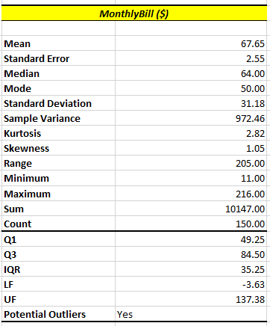

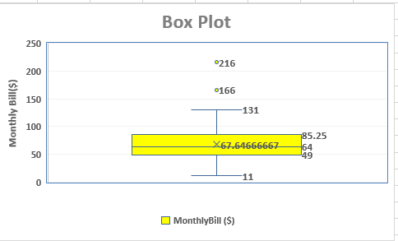

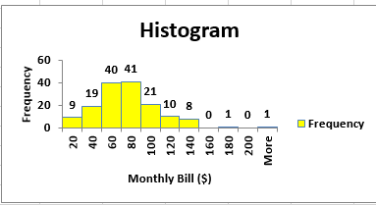

**Q2.a**

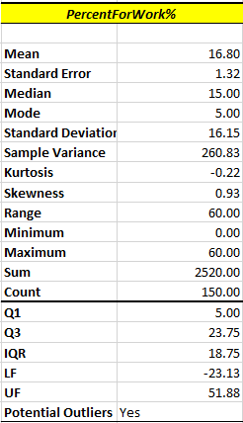

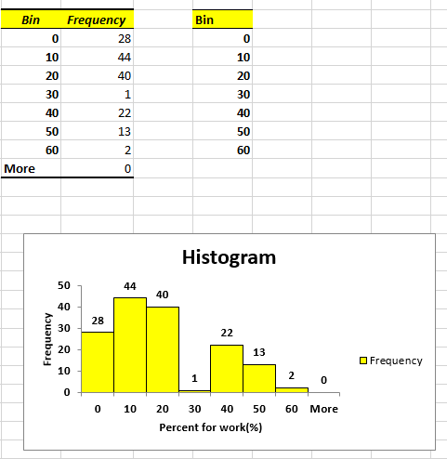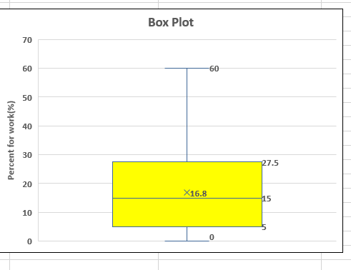

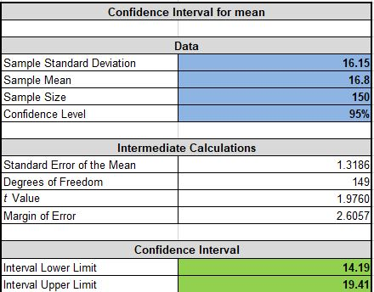

**Q2.b**

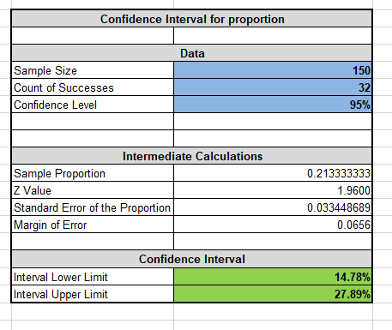

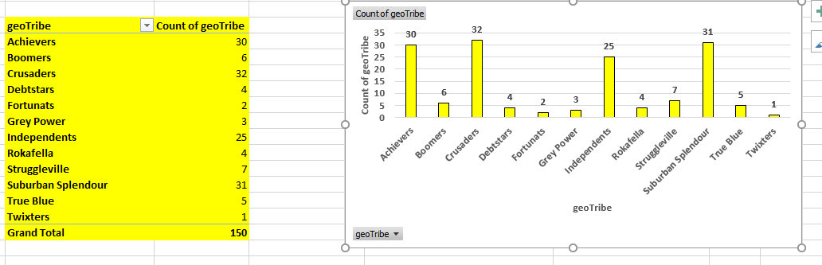

**Q3.a**



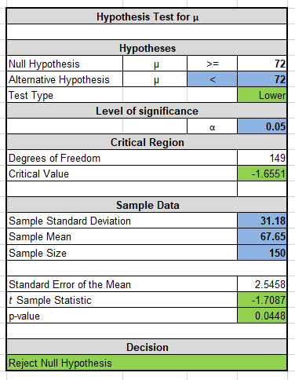

**Q3.b**

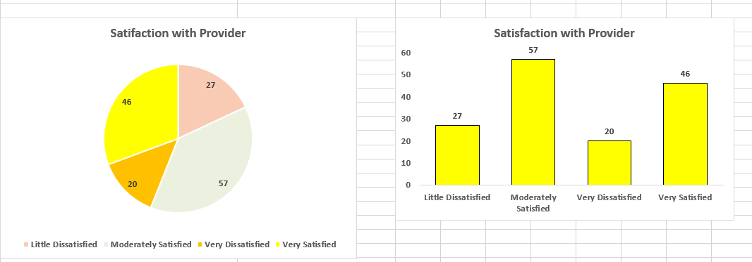

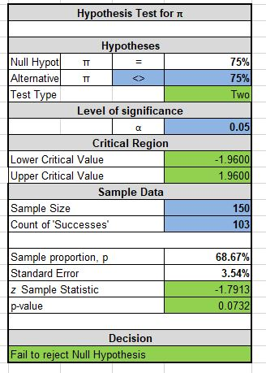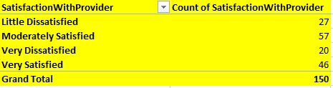

**Q3.c**

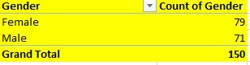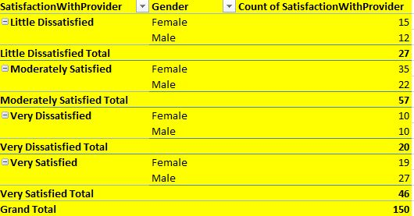

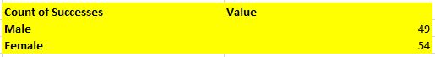

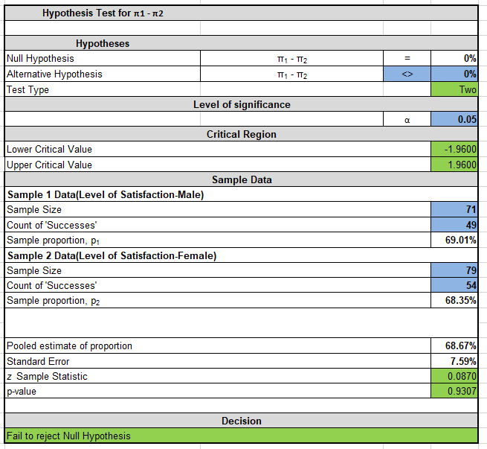

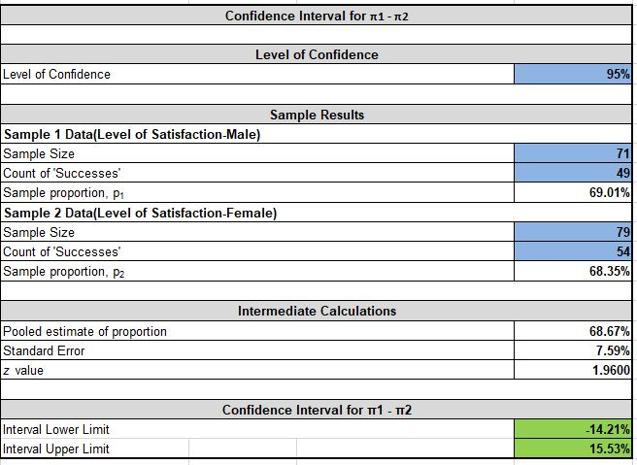

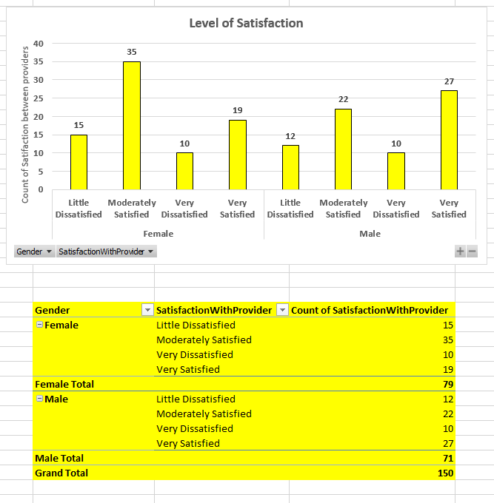

**Q3.d**

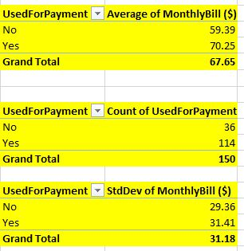

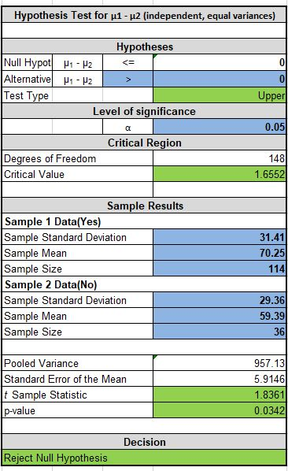

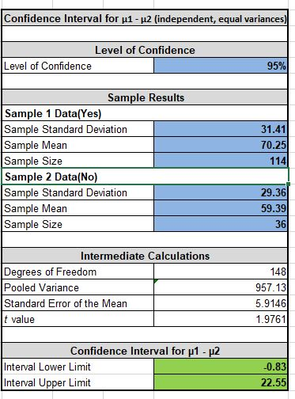

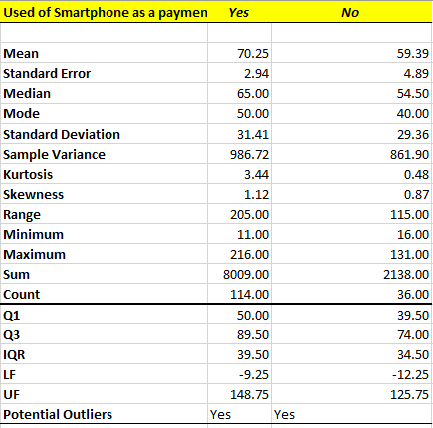

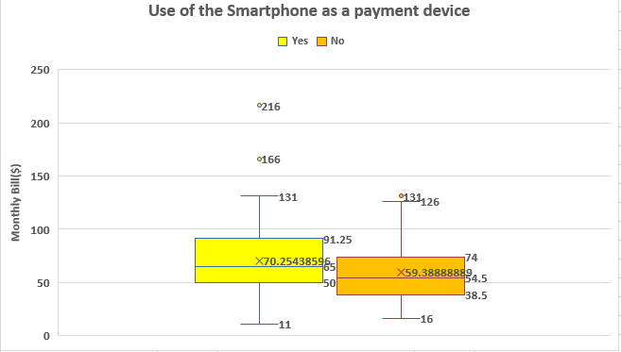

**Q3.e**

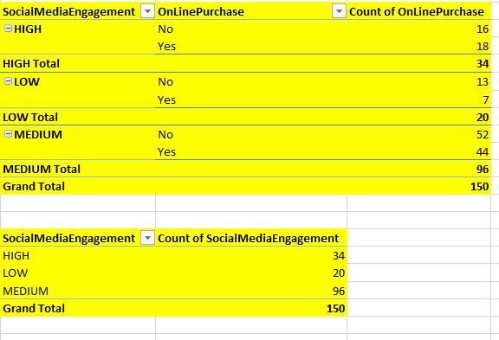

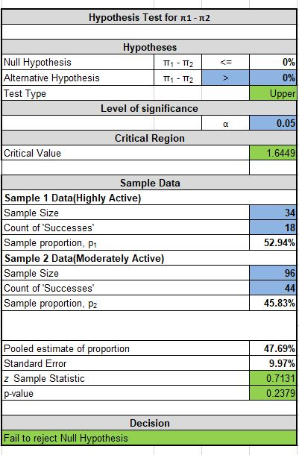

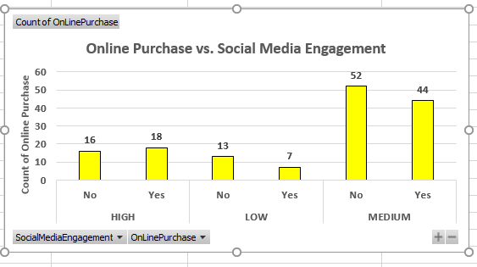

**Q4.a**

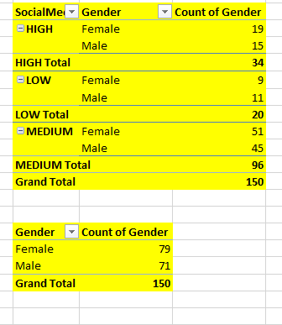

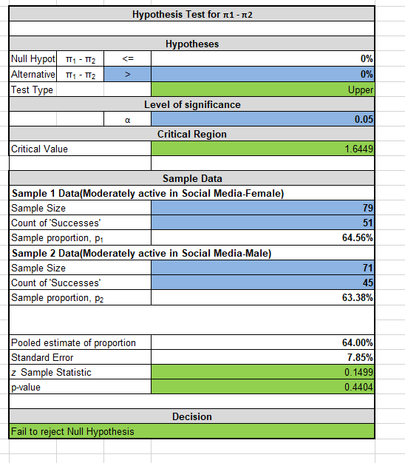

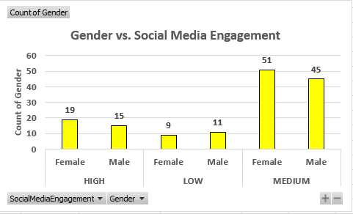

**Q4.b**

